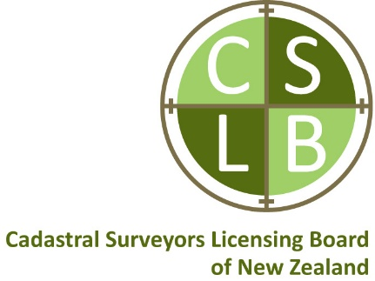

Date June 2026

Position Profile
Position Title Examinations Coordinator
Position Type Part Time - contract
Organisation Cadastral Surveyors Licensing Board of New Zealand
Location Unrestricted - remote
Reporting to Chair or responsible Board member

Overview

The Cadastral Surveyors Licensing Board of New Zealand (CSLB) are seeking a dedicated, skilled, highly organised and detail-oriented Examinations Coordinator on a part time contract basis to administer the new assessment framework that tests the competence of applicants seeking an initial licence to undertake cadastral surveys in New Zealand.

The Examinations Coordinator role requires skills in administration and coordination particularly in a modern learning and assessment context. Knowledge and ideally experience in cadastral surveying in New Zealand is advantageous. The coordinator will also need to develop a thorough understanding of the new Competency Assessment Framework.

The successful candidate will be required to have a flexible approach, as the role has varying time commitments over an annual cycle

Context

One of the key functions of the CSLB is to provide a regime to test the competence of those seeking a cadastral licence for the first time.

Competency Assessment Guideline March 2026
The assessment of applicants seeking an initial licence is undertaken by a panel of experts provided by Survey+Spatial New Zealand.

Key Responsibilities

- Assist with the ongoing implementation and management of the new Competency Assessment Framework.
- Coordinate and manage all aspects of the assessment and examination process, including scheduling, logistics, and communication with applicants and examiners.
- Develop and maintain examination and interview timetables, ensuring all deadlines are met.
- Administer the register of applicants.
- Liaise with the CSLB, assessors, and professional bodies to ensure compliance with assessment and examination requirements.
- Oversee the preparation and distribution of assessment and examination material.
- Undertake a quality assurance check to ensure all the necessary information has been received from applicants for assessment.
- Ensure the secure handling and storage of the assessment and examination material, including results.
- Provide support and guidance to applicants throughout the assessment process, including responding to their technical questions.
- Monitor and evaluate assessment processes, implementing improvements as needed.
- Liaise with third party platform provider.
- Handle inquiries and resolve issues relating to assessment and examinations in a timely and professional manner.
- Report to the CSLB on the implementation and operation of the framework.

Qualifications and Experience

- Excellent communication and interpersonal skills.
- Qualification or experience in cadastral surveying in New Zealand would be advantageous.
- Experience in examination coordination or a similar administrative role would be desirable.
- Attention to detail and a high level of accuracy.
- Proficiency in Microsoft Office Suite and learning management software (training in Moodle will be provided).
Anticipated Time Commitment

- 10 to 15 hours per week on average.
- A flexible approach is required, as the role has varying time commitments over an annual cycle including administration of and attendances at examinations.

Remuneration

- $100 per hour plus GST if applicable, together with monthly office allowance, subject to negotiation.
- One year contract with the expectation that it will be renewed following a review by both parties.

How to Apply

Interested candidates are invited to submit their resume and a cover letter outlining their qualifications and experience to the CSLB Secretary – secretary@cslb.org.nz by Monday 22nd June 2026.

